Sprint 3 - Agility Design Document

December 2, 2021
Table of Contents
1. Executive Summary 3
1.1 Project Overview 3
1.2 Purpose and Scope of this Specification 3
2. Product/Service Description 3
2.1 Product Context 3
2.2 User Characteristics 3
2.3 Assumptions 3
2.4 Constraints 3
2.5 Dependencies 4
3. Requirements 4
3.1 Functional Requirements 5
3.2 Security 5
3.2.1 Protection 5
3.2.2 Authorization and Authentication 6
3.3 Portability 6
4. Requirements Confirmation/Stakeholder sign-off 6
5. System Design 6
5.1 Algorithm 6
5.2 System Flow 6
5.3 Software 6
5.4 Hardware 6
5.5 Test Plan 7
5.6 Task List/Gantt Chart 7
5.7 Staffing Plan 7

Executive Summary

Project Overview
This project is a test for three developers to see all the steps in coding and developing a new program. The intended audience for this project is students and staff of Monmouth University.

Purpose and Scope of this Specification
The purpose of this specification for its intended audience is to see the limits of how far this robot can be pushed.
In scope
This document addresses requirements related to phase 1 of Project Robot:
- modification of speech to meet legislative mandate ENDUR_02.
- modification of circular movement to meet legislative mandate ENDUR_3.
Out of Scope
The following items in phase 2 of Project Robot are out of scope:
- modification of speed to meet legislative mandate ENDUR_4.

Product/Service Description
Some factors that could affect this product could include a water spill, a crack in the ground, bumps. The project also needs the Sphero Edu app to run.

Product Context
This product relates to other products independently. It interfaces with a variety of different smart phones. The product interfaces with phones created by Samsung and Apple.

User Characteristics
- Student-low level experience/low-level technical expertise
- Faculty- mid level experience/mid-level technical expertise
- Staff-high level experience/maximum level technical expertise
- Other-no experience/no technical expertise

Assumptions
As long as a person has a phone and can press the start button, they can run the program if given the code. No prior experience or technical expertise is required because the program can run on its own.

Constraints
- Robot can only be controlled from a certain distance
- Only block code can be used
- Only phones can control the robot

Dependencies
- This new product will require the Sphero Edu app to be downloaded
- Bluetooth will be needed
- A stable Wi-Fi connection will be needed

Requirements

Functional Requirements
Req# | Requirement | Comments | Priority | Date Rvwd | SME Reviewed / Approved
ENDUR_01 | Robot can avoid 1st bottle | Robot avoided 1st bottle | 2 | 11/30 | Bryn
ENDUR_02 | Robot can avoid 2nd bottle | Robot avoided 2nd bottle | 2 | 11/30 | Bryn
ENDUR_03 | Robot can avoid 3rd bottle | Robot avoided 3rd bottle | 2 | 11/30 | Bryn
ENDUR_04 | Robot can get over the ramp | Robot got over the ramp | 1 | 12/2 | Bryn
ENDUR_05 | Robot can knock over a few pins | Robot was able to knock over a few pins | 1 | 12/2 | Bryn
ENDUR_06 | Robot can knock over all pins | Robot didn’t knock over all pins | 3 | 12/2 | Bryn

Security

Protection
- Finger encryption
- Facial recognition
- Pattern lock
- Number lock

Authorization and Authentication
No authorization was required because all activities were handled in person.

Portability
- Percentage of components with host-dependent code: 50%
- Percentage of code that is host dependent: 100%
- proven portable language: none
- compiler or language subset: block code
- operating system: iOS/android
- environment-independence: full independence

Requirements Confirmation/Stakeholder sign-off

Meeting Date | Attendees (name and role) | Comments
11/04/21 | Bryn, Taye, Adnan | confirmed all except ENDUR_05 and ENDUR_06
11/08/21 | Bryn, Taye, Adnan | Confirmed ENDUR_05 and ENDUR_06

System Design

Algorithm
- Start
- Move diagonally to the left
- Stop
- Move diagonally to the right
- Stop
- Move diagonally to the left
- Stop
- Move diagonally to the Right
- Jump over ramp
- Move back
- Stop

System Flow
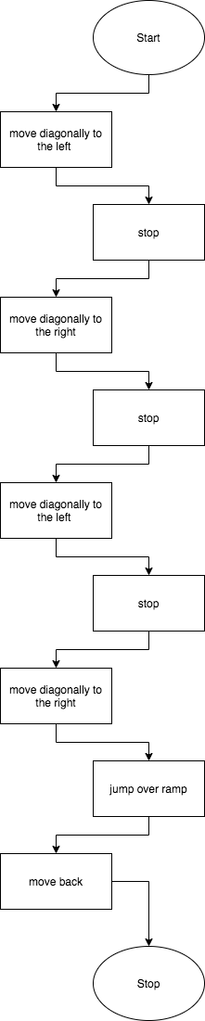

Software
The software language used to develop and deploy this application was block code. This form of code divides and stacks different parts of the task at hand. Block coding is a beginner level of code because pieces of code are given to you and the only thing you must do is connect the pieces of the puzzle.

Hardware
The hardware platforms that were used to develop, test, and demonstrate this application included an iPhone a Samsung Galaxy, and the robot itself. Each phone was used to develop the block code that ran the robot. The robot was used to test and demonstrate this application.

Test Plan
Reason for Test Case | Test Date | Expected Output | Observed Output | Staff Name | Pass/Fail
Pathfinding 1 | 11/30 | The robot should be able to make it around the 1st bottle | The robot made it around the 1st bottle | Bryn, Taye, Adnan | Pass
Pathfinding 2 | 11/30 | The robot can make it around the 2nd bottle | The robot made it around the 2nd bottle | Bryn, Taye, Adnan | Pass
Pathfinding 3 | 11/30 | The robot can make it around the 3rd bottle | The robot made it around the 3rd bottle | Bryn, Taye, Adnan | Pass
Pathfinding 4 | 11/30 | The robot can reach checkpoint 1 | The robot reached checkpoint 1 | Bryn, Taye, Adnan | Pass
Pathfinding 5 | 12/2 | The robot can get over the ramp to checkpoint 2 | The robot got over the ramp to checkpoint 2 | Bryn, Taye, Adnan | Pass
Pathfinding 6 | 12/2 | The robot makes it to the finish and knocks over some pins | The robot made it to the finish and knocked over some pins | Bryn, Taye, Adnan | Pass

Task List/Gantt Chart
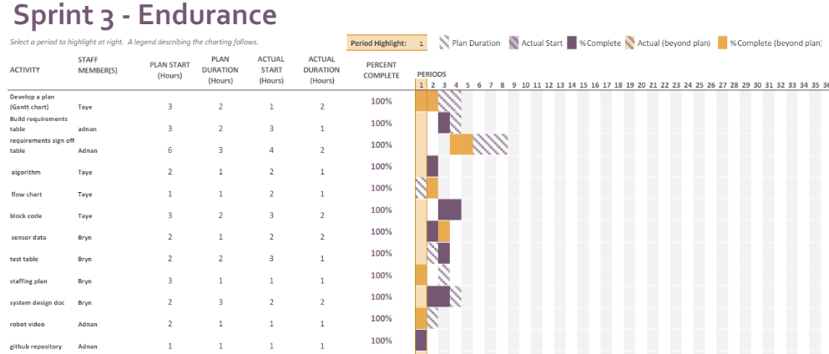

Staffing Plan
Name | Role | Responsibility | Reports To
Bryn | Project Manager | Oversee and plan development/create system design document | N/A
Taye | Developer | Create Gantt chart/algorithm/flow chart | Bryn
Adnan | Developer | Develop block code/upload censor data | Bryn

Sensor Data Program

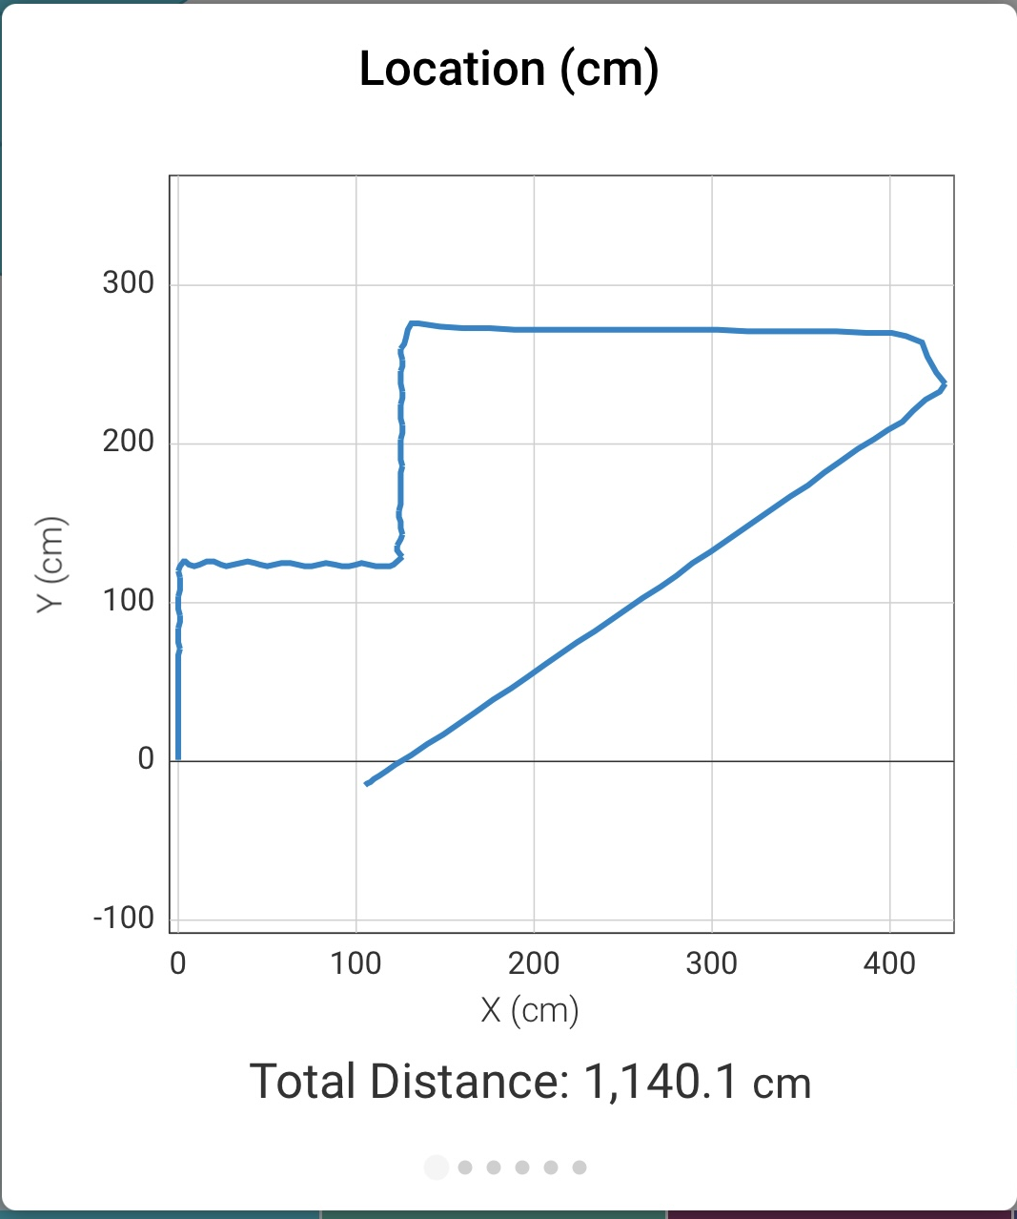

Block Code
